**TEAM NAME :** CallResponders

**PROJECT NAME :** Home Cure Bot

**ABOUT THE PROJECT :**

COVID-19, a very unexpected and a shaking pandemic that the world is facing from around the end of 2019. After the worldwide outbreak of COVID-19, the number of patients in the hospitals is increasing day by day, leading to more and more cases each day. In such a situation, if people want to visit the hospital for any minor illness, health complaints or injuries, they cannot do so, because neither do they want to risk going to the hospital, nor are the doctors available to treat them.

This Chat Bot project, is thus designed to help in such situations, where the treatment can be majorly done at home, so as to avoid going to the hospitals unless extremely.

It is developed using the Watson Assistant IBM Service. When a user enters a problem they are facing which maybe burns, cuts, wounds, dizziness, nausea, splinters, fractures, strains and sprains, stings, heart burn, etc., the Chat Bot gives description about the ailment, symptoms to make sure that the person is sure of the problem, followed by remedies that can be taken at home to cure them. Plus, the Chat Bot also tells when does the problem require a serious medical attention so that only then the user can go to the hospital. Also suppose the user is not sure about what is the problem they are having then they can put a symptom and the Chat Bot gives user options with more symptoms and on the basis of what the user selects the possible diagnosis and remedy is suggested. Say for example a person twisted his/her ankle, then the person asks the Chat Bot for remedy, the Chat Bot helps him/her recognize if it is a sprain or a fracture and then suggest remedies accordingly.

Building Chat Bot consists of constructing three things: intents, entities and dialogs.

Where intent refers to the goal the customer has in mind when typing in a question or comment. While entity refers to the modifier the customer uses to describe their issue, intent is what they really mean. Consider one such example ailment below which is constructed as follows:

Suppose the user asks about chest pain. So, an intent is created beforehand to train the bot which consists possible queries a user can make such as “I am feeling uneasiness around my chest”, etc.

Now for the entity part which is for values or what you call as options for the chest pain that when additional symptoms given to user to choose among the following three, one such option is chosen corresponding to the option chosen by the user:

1. Asthma attack

2. Acid Reflux Problem

3. Heart attack

Now the dialog part which is the solution for the problems related to chest pain

i. If the Chat Bot recognizes it to be an Asthma Attack then it responds with their corresponding remedies

ii. If the Chat Bot recognizes it to be an Acid Reflux problem then it responds with their corresponding remedies

iii. If the Chat Bot recognizes it to be a Heart attack then it responds with their corresponding remedies

Facebook is the user interface which is used by many people

The home cure bot is directly integrated with Facebook by creating a new page for the bot and through the messenger the user can easily chat with the bot.

Therefore, this bot is helpful, as it can be used from home, and is designed to be user friendly.

To summarize it up, this Chat Bot helps the user in the following ways:

• Helps to know what steps should be taken to treat the injury or wound.

• Helps to know what exactly happened, so that the user is not confused and does not take the wrong remedies.

• It gives you the serious symptoms too, so that you can know when to seek medical attention.

**SOLUTION ARCHITECTURE:**

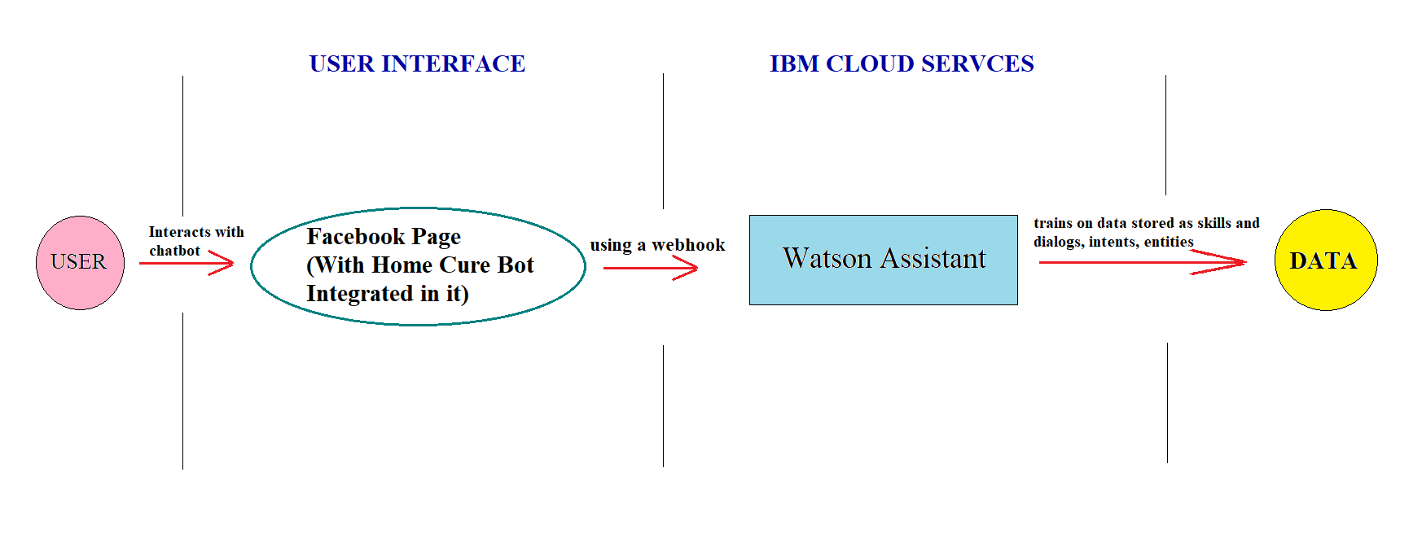

**IBM CLOUD SERVICES/SYSTEMS:**

IBM Watson Assistant

**FUTURE SCOPE:**

This chatbot gives the remedies and treatments that can be done from home. Improvements can definitely be made, for:

Uploading an image of the injury or problem faced, so that it can tell the user what exactly happened, if the user doesn’t know.

Including few more problems like fits, fainting, head injuries etc.

Connecting to a Doctor on Facebook, if medical attention is needed.

**TEAM MEMBERS DETAILS:**

|  |  |
| --- | --- |
| **NAME** | **E-Mail IDs** |
| Zeenat Sehar | zs201721@gmail.com |
| Nikhat Parveen | nikhat3158@gmail.com |
| Syeda Aayesha Kaleem | kalis24.sgai@gmail.com |